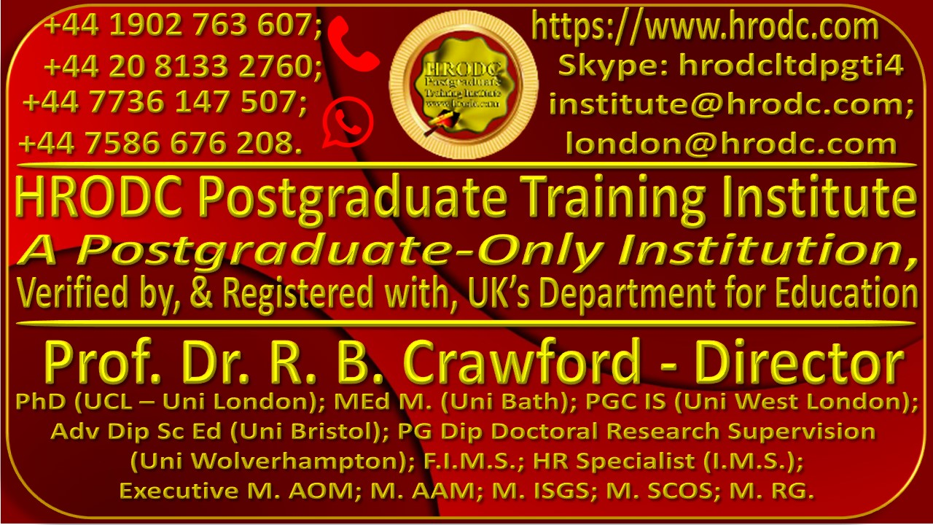
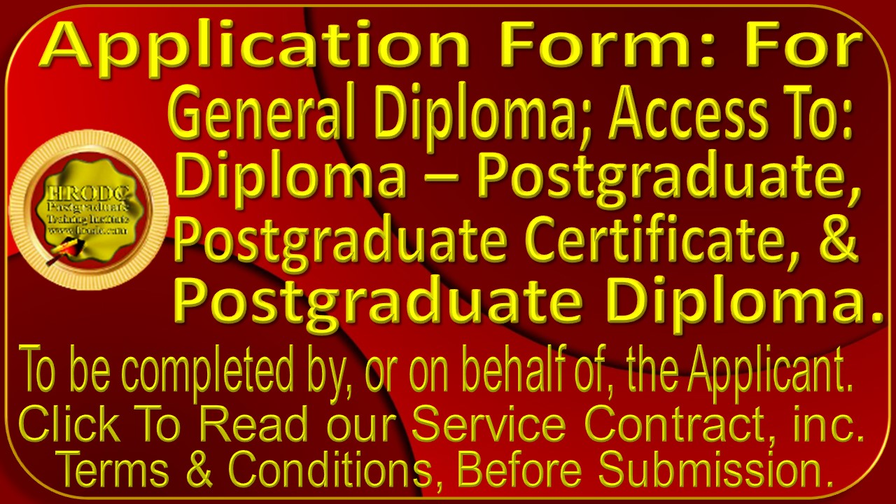

It is expected that this Application Form will be completed and submitted electronically, in this Format. PDF and Graphic Formats are unacceptable.
Please affix a recent picture of the Applicant, here

General Information
First Name & Middle Name | Surname | Title (Dr. /Prof/ Ms / etc.)
Date of Birth | Gender (Male/ Female/ etc.) | Nationality
Permanent Address
Temporary Address
Home Telephone Number | Work Telephone Number | Email Address
Name & Address of Employer | Role/ Position | Work Telephone #
Are You being Sponsored? | If yes, Details of Sponsor.

Chronological Education : College & University
In the spaces below, please enter, in chronological order, all relevant details pertaining to the Colleges and, or, Universities that you attended. Please add as many rows as you require.
Period {From – To (Day; Month; & Year)} | Name & Address of Institution | Subjects Studied | Award (Qualification) Gained

Non-Award Bearing Courses Taken
Please give details, below, of any non-award-bearing courses that you may have taken
Name of Course | Name and Address of Organising Body | Course Duration | Period: From; To (Date; Month; Year)

Professional Experience
Please provide details of your current and previous employment, in reverse chronological order (starting with you current employment)
Period: From; To (Date; Month; Year) | Name, Address, & Telephone Number of Employer | Role (Position Held) | Duties & Responsibilities.

English Proficiency
If English is not your native language, we require evidence of your level of proficiency in spoken and written English. If you do not already hold an acceptable qualification in English (e.g. IELTS or TOEFL), you may be required to obtain one before you can be admitted to our Postgraduate Programmes and Courses.
Type of Test | Overall Score | Reading | Writing | Speaking | Listening
IELTS

TOEFL
Cambridge Tests
Other English Language
Qualification

Select Your Postgraduate Programme or Course.
In the spaces below, please provide details of the Postgraduate Programme or Course that you wish to embark on, after the successful completion of the General Diploma. Please omit any information of which you are uncertain.
Name and number of Postgraduate Programme or Course | Expected Start Date

Study Mode Choice
Kindly specify your preferred Study Mode. Scholarship Recipients are allowed Online Mode, only. Please place an ‘X’ in the relevant space to confirm your choice.
Intensive Full-Time (6 hours per day, 5 days weekly). 3 months’ duration | Full-Time [15 hours ( 2 days) per week]. 6 months’ duration. | Online (3 hours per day; 6 days weekly (20 weeks’ duration; or 3 hours per day, 5 days weekly (25 weeks’ duration).

Task 1: Costing Capital Expenditure
You have just been promoted to the Position of Senior Vice President, Procurement, in your Organisation. Your role incorporates the projected Capital Expenditure for the next Financial Year. Having received requisitions from the relevant departments, you need to present a comprehensive budget to your President. Please calculate the individual and total expenditure, with and without the relevant taxes (Stamp Duty Land Tax (SDLT), Sales Tax; Import Tax, Environmental Tax), at an average of 20%.
Item | Cost | Tax | Total Cost
New office building | $10,000,000.00
Renovations to existing building | $100,000.00
Land purchase | $500,000.00
Laboratory equipment | $20,000.00
ICT infrastructure upgrade | $80,000.00
Heavy machinery for construction | $500,000.00
Total: | $ | $ | $

Tasks 2: Justification For My Sponsorship
You are being sponsored by your organisation to study our General Diploma, and, subsequently, a Postgraduate Diploma. Write a letter to your Chief Executive, justifying the expenditure onyour Education and Training. You should explain how you will utilize your new knowledge, skills, and expertise towards organisational improvement. Your letter should be under the heading: “My Sponsorship As an Investment”. Your discussion will focus on how your return will improve the organisation’s functioning and objective accomplishment. Try to provide concrete examples of how you will utilize your new knowledge and skills. Include any measurable outcomes that will demonstrate how your organisation will measure the return on its investment in your education and training. It will be helpful if you specify how long, after your return, it will take for you to implement your newly acquired knowledge, skills, and expertise, for the expected results to be evident. Create more space, if needed.

Task 3. My Aspiration For the Next Ten Years.
In the space provided, below, please write an essay entitled: “My Aspiration For The Next Ten Years”. You should indicate how your General Diploma and Postgraduate Diploma will improve your personal, academic, and professional life.
- It should chart your career path and the achievements you aspire towards. Consider the challenges you hope to overcome in the next decade;
- Incorporate the skills, knowledge, and expertise you hope to acquire;
- How do you see your role evolving within your profession or occupation?
- What impact do you aspire to make on your organization or community?
We are expecting a length of at least two thousand five hundred characters, with no verbosity. Assessment will relate to the extent to which you are realistic ambition, the clarity that you bring to the fore, and you Use of English, Grammar and Punctuation.
Please create more space if you need to.

Task 4: Creating a Coherent Paragraph.
Below is a short paragraph, with the sentences separated, for simplicity. Please reorder the sentences in the correct sequence.
Current Order of Sentences
We will have a great time together.
I am going to the park.
He loves to play fetch.
The sun is shining.
I will take my dog with me.

Correct Sequence of Sentences

Task 5: UK Date Format.
Please convert the following dates to the UK Abbreviated Date Format. The first one has been done for you.
# | Date in Full | UK Abbreviated Date
 | September 14, 2023 | 14/09/2023
 | January 25, 2022
 | February 05, 2024
 | March 23, 2025
 | April 11, 2019
 | May 01, 2027
 | June 20, 2020
 | July 15, 2019
 | August 18, 2025
 | September 02, 2009

Additional Information
in the space provided below, please provide us with any additional information that will support your Application. You might create additional space, if needed.

Your Referees
Please provide us with the contact details of 2 referees, one of whom should be a trainer or academic and the other your manager or supervisor. Character References or Testimonials are not needed.
Referee Information | Referee #1 | Referee #2
Name of Referee:
Referee’s Role (Position)
Your Relationship with Referee: (e.g. Tutor, Trainer, Manager, Supervisor):
Name & Address of Referee’s Organisation:
Referee’s Email Address:
Referee Telephone Number/s:

Name Format For Award Issuance
Please Write your Names, below, in the precise order, spelling and format that you would like them to appear on your Award.

Promotional Monitoring
kindly help us to monitor our promotional effort by indicating your source of information about HRODC Courses. Please tick the appropriate column
Our Website/s: |  | Facebook (Meta) Post:
Other Website: |  | Instagram Post
Your Colleague: |  | ‘X’ (Twitter) Post:
Your Line Manager: |  | LinkedIn Post:
Your Workplace’s Information Board: |  | Pinterest Post:
Your Training Manager: |  | Tumblr Post:
Your Friend: |  | Google Blog:
A Family Member: |  | Google Business:
Other definitive source: |  | Other unknown Source:

Special Needs Requirements
In an effort to promote inclusivity, we would appreciate it if you would indicate the type of special needs that you might have, ticking the appropriate column, in you have none.
Blind or partially sighted |  | Mental Health difficulties
Deaf or hearing impaired |  | No special needs
Need for personal care support |  | Other special needs (please specify)
Other; please specify::

Our Branded Complimentary Polo Shirts
- At the beginning of each General Diploma, Postgraduate Programme, or Postgraduate Course, Delegates and Students will receive a Branded Polo Shirt, along with a choice of other Complimentary Products.
- The above does not apply to Scholarship Recipients. However, any of our Complimentary Products might be bought for a modest price.
- Kindly complete the sections below, to ensure your best chance of getting your preferred Institute Polo Shirt colour and size. You may select more than one colour, in the event that your preferred choice is unavailable.
Please see Size Conversion Chart and Picture of Polo Shirt, below!

Polo Shirt Colours
Please Choose Two Polo Shirt Colours, Below, Denoting “1” and 1st Choice & “2” as Second.
Red | Sky blue | Black | Dark Blue | White | Green

Polo Shirt Size Choice
Please select your Polo Shirt Size, using the charts, below, as a guide.

Polo Shirt Size Guide
Men’s Shirt Sizes | Women’s Shirt Sises
Size Chest Neck  S 36 14-14.5  M 38-40 15-15.5  L 42-44 16-16.5  XL 46-48 17-17.5  XXL 50-52 18-18.5  3XL 54-56 19-19.5  4XL 58-60 20-20.5 | Size Numeric Size Chest  XS 4 32.5  S 6/8 35  M 10/12 37.5  L 14/16 40.5  XL 18/20 43.5  2XL 22/24 46.5

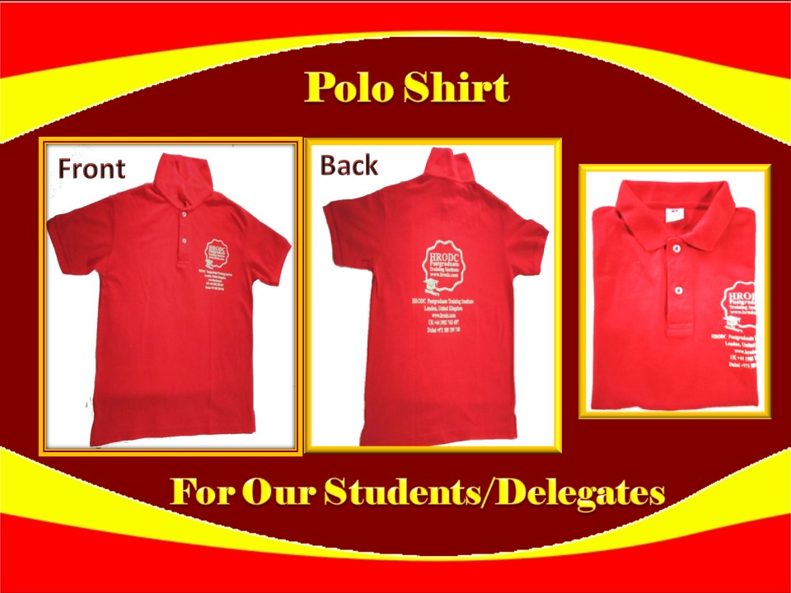

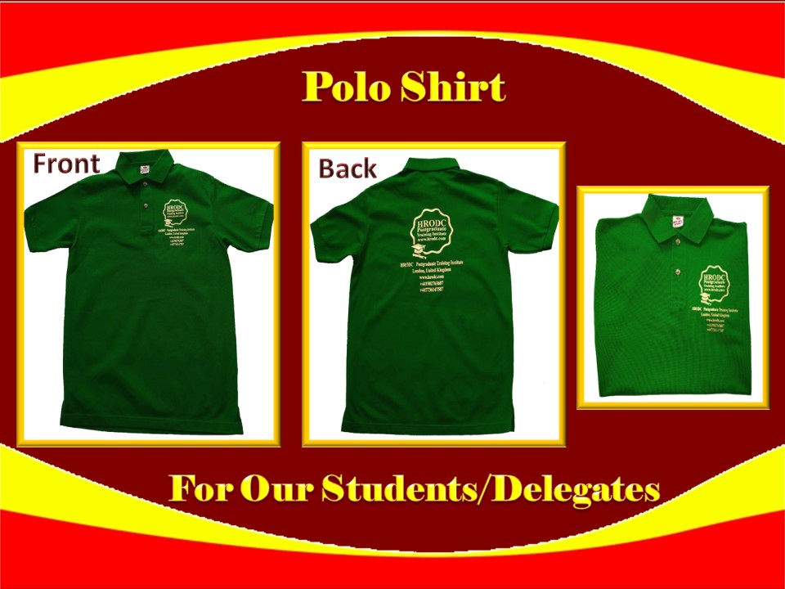

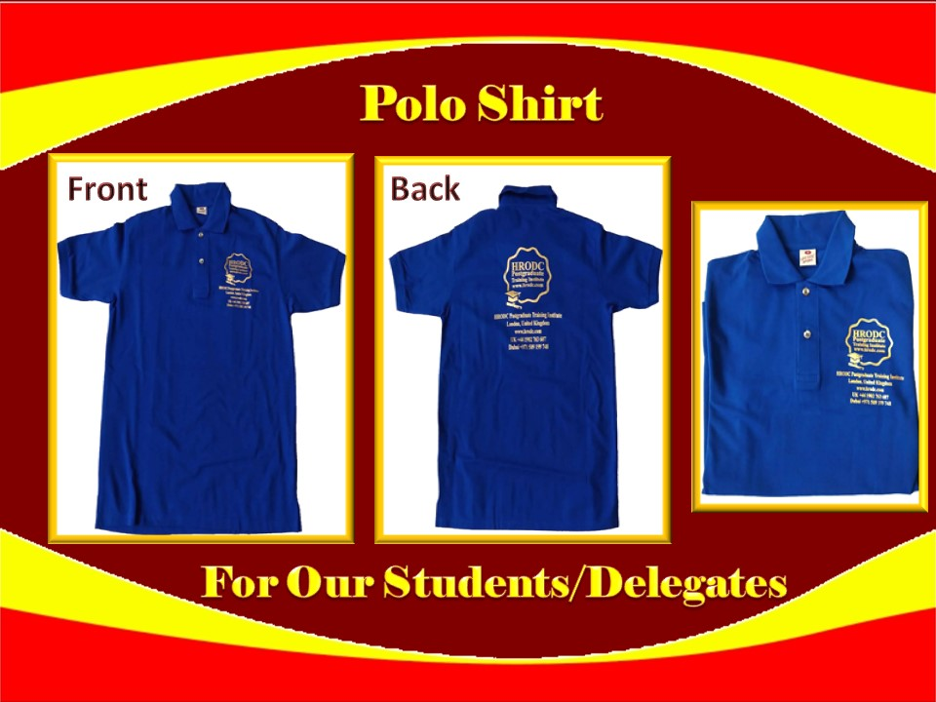

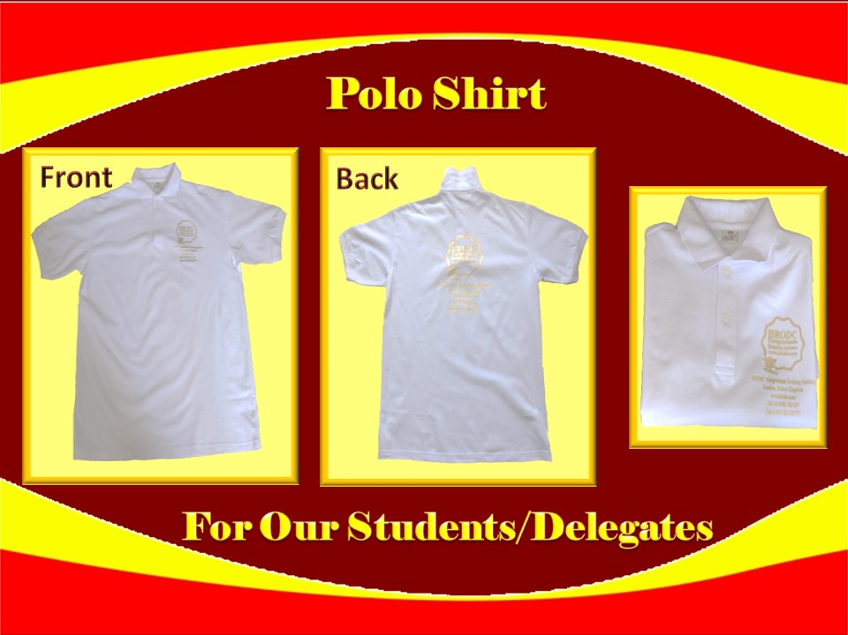

Final Declaration
Kindly read and sign the declaration, below, making correction to any aspect of the information that precedes it, before submitting this form.
I hereby certify that the information that I have provided on this form is accurate and that I have not knowingly been deceptive. I am aware that any offer of a place on HRODC Postgraduate Training Institute’s Postgraduate Programmes and Short Courses that I may receive, will be based on the information that I have provided hereon, and that if I am found to have given false information, the offer of a place on the Programme or Course/s being applied for, may be withdrawn.

I am aware that the information supplied on this form will be retained by this Institute and will be used for the purpose of processing my application. Also, if my application is successful the information will form part of my student/delegate record.
Your Full Name | Date of Application | Your Signature

