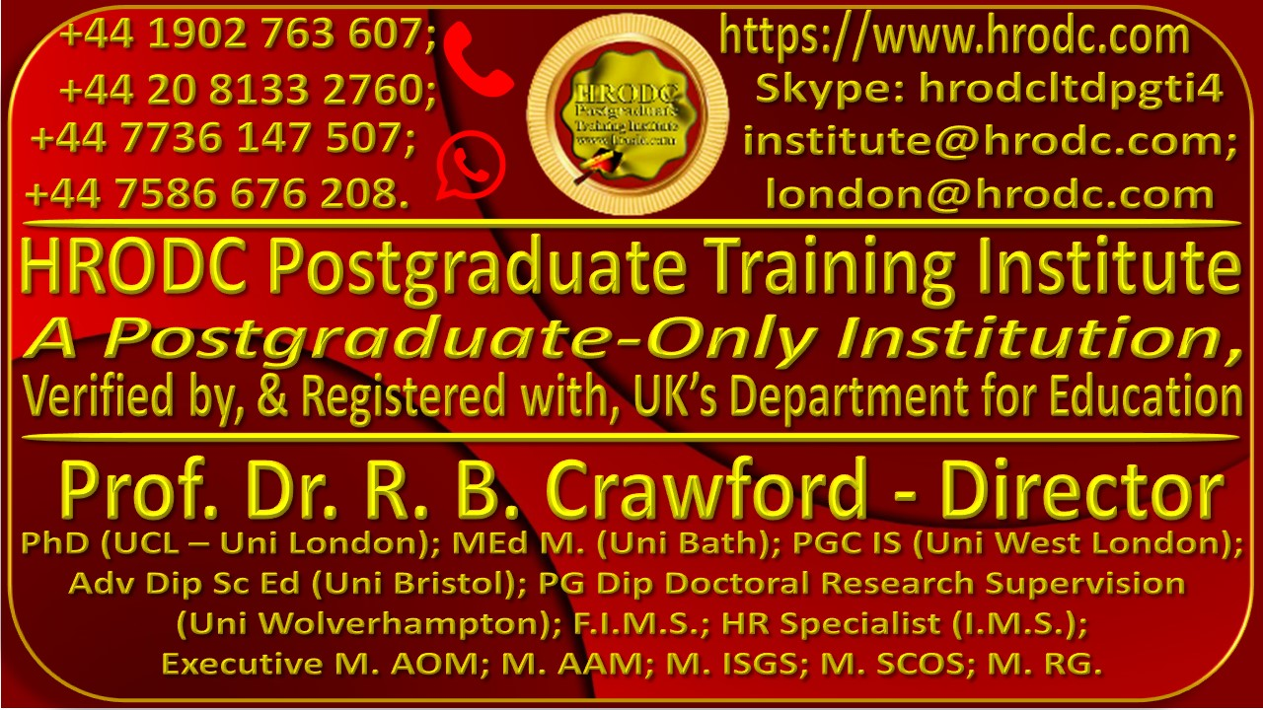
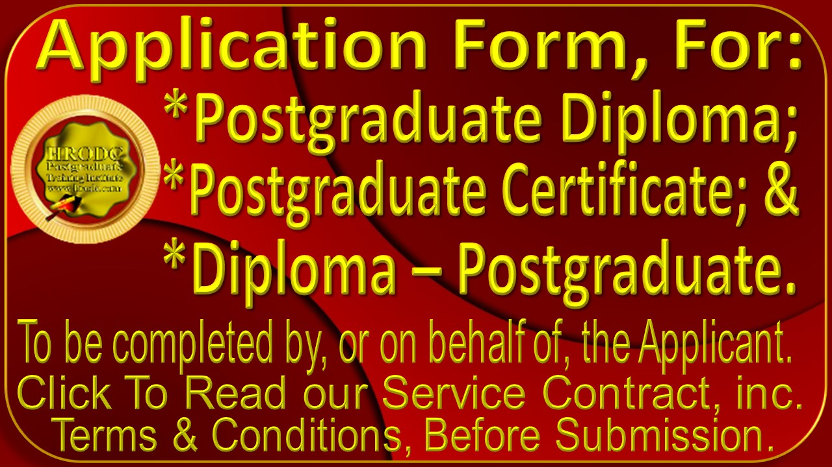

It is expected that this Application Form will be completed and submitted electronically, in this Format. PDF and Graphic Formats are unacceptable.
Please affix a recent picture of the Applicant, here

General Information
First Name & Middle Name | Surname | Title (Dr. /Prof/ Ms / etc.)
Date of Birth | Gender (Male/ Female/ etc.) | Nationality
Permanent Address
Temporary Address
Home Telephone Number | Work Telephone Number | Email Address
Name & Address of Employer | Role/ Position | Work Telephone #
Are You being Sponsored? | If yes, Details of Sponsor.

1st Programme or Course For Which You are Seeking Admission
Programme or Course Number & Name |  | Expected Start Date
In-Venues or Online? | Preferred In-venues Location | Alternative Location

2nd Programme or Course For Which You are Seeking Admission
Programme or Course Number & Name |  | Expected Start Date
In-Venues or Online? | Preferred In-venues Location | Alternative Location

Chronological Education : College & University
In the spaces below, please enter, in chronological order, all relevant details pertaining to the Colleges and, or, Universities that you attended. Please add as many rows as you require.
Period {From – To (Day; Month; & Year)} | Name & Address of Institution | Subjects Studied | Award (Qualification) Gained

Non-Award Bearing Courses Taken
Please give details, below, of any non-award-bearing courses that you may have taken
Name of Course | Name and Address of Organising Body | Course Duration | Period: From; To (Date; Month; Year)

Professional Experience
Please provide details of your current and previous employment, in reverse chronological order (starting with you current employment)
Period: From; To (Date; Month; Year) | Name, Address, & Telephone Number of Employer | Role (Position Held) | Duties & Responsibilities.

English Proficiency
If English is not your native language, we require evidence of your level of proficiency in spoken and written English. If you do not already hold an acceptable qualification in English (e.g. IELTS or TOEFL), you may be required to obtain one before you can be admitted to our Postgraduate Programmes and Courses.
Type of Test | Overall Score | Reading | Writing | Speaking | Listening
IELTS

TOEFL
Cambridge Tests
Other English Language
Qualification

Additional Information
in the space provided below, please provide us with any additional information that will support your Application. You might create additional space, if needed.

Your Referees
Please provide us with the contact details of 2 referees, one of whom should be a trainer or academic and the other your manager or supervisor. Character References or Testimonials are not needed.
Referee Information | Referee #1 | Referee #2
Name of Referee:
Referee’s Role (Position)
Your Relationship with Referee: (e.g. Tutor, Trainer, Manager, Supervisor):
Name & Address of Referee’s Organisation:
Referee’s Email Address:
Referee Telephone Number/s:

Study Mode Choice
Kindly specify your preferred Study Mode. Scholarship Recipients are allowed Online Mode, only. Please place an ‘X’ in the relevant space to confirm your choice.
Intensive Full-Time (6 hours per day, 5 days weekly). 3 months’ duration | Full-Time [15 hours ( 2 days) per week]. 6 months’ duration. | Online (3 hours per day; 6 days weekly (20 weeks’ duration; or 3 hours per day, 5 days weekly (25 weeks’ duration).

Name Format For Award Issuance
Please Write your Names, below, in the precise order, spelling and format that you would like them to appear on your Award.

Promotional Monitoring
kindly help us to monitor our promotional effort by indicating your source of information about HRODC Courses. Please tick the appropriate column
Our Website/s: |  | Facebook (Meta) Post:
Other Website: |  | Instagram Post
Your Colleague: |  | ‘X’ (Twitter) Post:
Your Line Manager: |  | LinkedIn Post:
Your Workplace’s Information Board: |  | Pinterest Post:
Your Training Manager: |  | Tumblr Post:
Your Friend: |  | Google Blog:
A Family Member: |  | Google Business:
Other definitive source: |  | Other unknown Source:

Special Needs Requirements
In an effort to promote inclusivity, we would appreciate it if you would indicate the type of special needs that you might have, ticking the appropriate column, in you have none.
Blind or partially sighted |  | Mental Health difficulties
Deaf or hearing impaired |  | No special needs
Need for personal care support |  | Other special needs (please specify)
Other; please specify::

Our Branded Complimentary Polo Shirts
- At the beginning of each General Diploma, Postgraduate Programme, or Postgraduate Course, Delegates and Students will receive a Branded Polo Shirt, along with a choice of other Complimentary Products.
- The above does not apply to Scholarship Recipients. However, any of our Complimentary Products might be bought for a modest price.
- Kindly complete the sections below, to ensure your best chance of getting your preferred Institute Polo Shirt colour and size. You may select more than one colour, in the event that your preferred choice is unavailable.
Please see Size Conversion Chart and Picture of Polo Shirt, below!

Polo Shirt Colours
Please Choose Two Polo Shirt Colours, Below, Denoting “1” and 1st Choice & “2” as Second.
Red | Sky blue | Black | Dark Blue | White | Green

Polo Shirt Size Choice
Please select your Polo Shirt Size, using the charts, below, as a guide.

Polo Shirt Size Guide
Men’s Shirt Sizes | Women’s Shirt Sises
Size Chest Neck  S 36 14-14.5  M 38-40 15-15.5  L 42-44 16-16.5  XL 46-48 17-17.5  XXL 50-52 18-18.5  3XL 54-56 19-19.5  4XL 58-60 20-20.5 | Size Numeric Size Chest  XS 4 32.5  S 6/8 35  M 10/12 37.5  L 14/16 40.5  XL 18/20 43.5  2XL 22/24 46.5

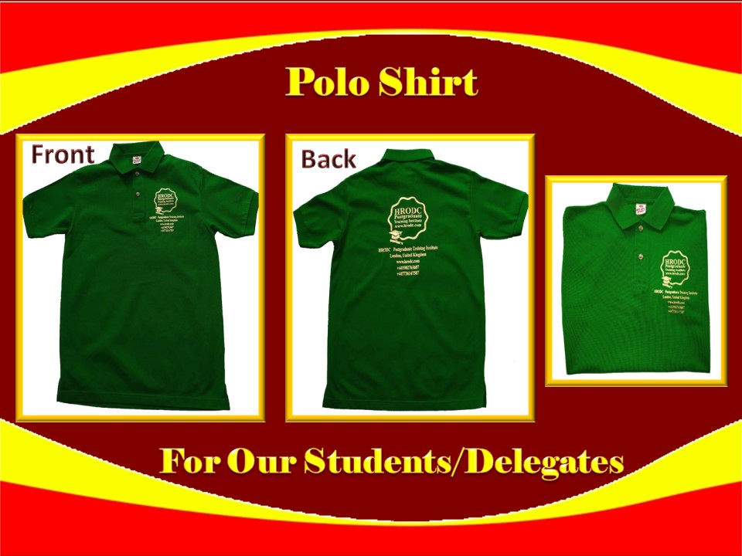

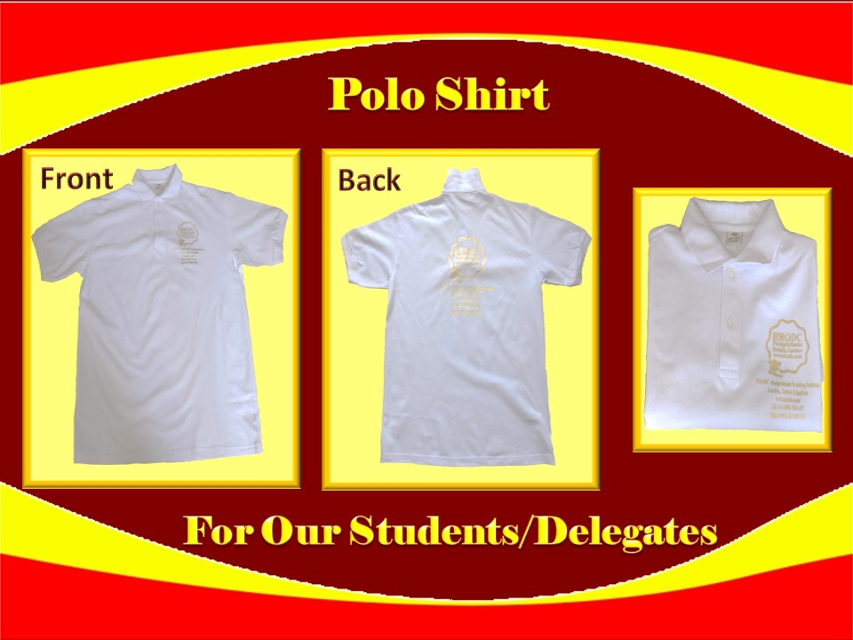

Final Declaration
Kindly read and sign the declaration, below, making correction to any aspect of the information that precedes it, before submitting this form.
I hereby certify that the information that I have provided on this form is accurate and that I have not knowingly been deceptive. I am aware that any offer of a place on HRODC Postgraduate Training Institute’s Postgraduate Programmes and Short Courses that I may receive, will be based on the information that I have provided hereon, and that if I am found to have given false information, the offer of a place on the Programme or Course/s being applied for, may be withdrawn.

I am aware that the information supplied on this form will be retained by this Institute and will be used for the purpose of processing my application. Also, if my application is successful the information will form part of my student/delegate record.

Your Full Name | Date of Application | Your Signature

